**Document 01 – Project Description**

1. **Overview**

This document is informational. There is nothing to do, *per se*, or turn in.

You will build an API for a *Doctor’s Office Management System.* Initially, you will be concerned with the relationships shown in the class diagram below:



As development unfolds, you will be introducing additional classes. For example, the system may evolve this way:

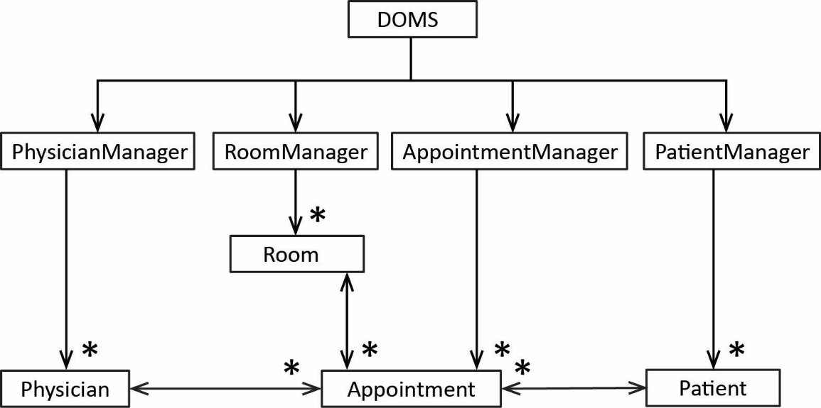

During Sprint 1, you will:

* Create a set of use cases and an initial design for this system
* Code an API to support the use cases. The system must be object oriented. At this point data persistence and a user interface will not be considered.
* Create a report detailing the use cases you have delivered and the final design.